**In-Class Task 4 Instructions: Debug the MPG application**

This In-Class Task gives you a chance to use your debugging skills to find the cause of an error. Estimated time: 5 to 15 minutes.

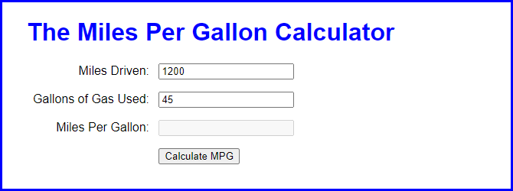

1. Open the application in this folder:

Evaluation\In-Class Tasks\In-Class Task 3\mpg.zip

1. Start the application, enter the values shown above, and click on the Calculate MPG button. Nothing happens.
2. Use Chrome’s developer tools to find the cause or causes of the problem. Then, use your IDE or text editor to fix the code.
3. Start the application again, enter the values shown above, and click on the Calculate MPG button. This time, 27 will be displayed in the Miles Per Gallon text box.
4. Fix the application so the miles per gallon will be displayed with one decimal place.